**INDIVIDUAL ANALYSIS REPORT**

Group C1.04.05

20/03/2023

Author(s):

Carlos Zarzuela Reina, [carzarrei@alum.us.es](mailto:carzarrei@alum.us.es)

**Table of contents**

**Table of contents** **2**

**1. Executive summary** **3**

**2. Revision table** **3**

**3. Introduction** **3**

**4. Contents** **3**

4.1. Performed tasks 3

4.2. Budget 4

**5. Conclusions** **4**

**6. Bibliography** **4**

1. **Executive summary**

This report summarizes the analysis needed for the second deliverable for Carlos Zarzuela Reina’s work.

1. **Revision table**

| **No** | **Date** | **Description** |
| --- | --- | --- |
| 1.0 | 20/03/2023 | Initial draft of the document. |

1. **Introduction**

The analysis of the requirements is fundamental in every project to get the necessities of the customer right and understand the domain with precision. The documents provided to us already give a detailed expression of what the requirements might be and what they need to be completely fulfilled. If any of those requirements implores extra analysis it will be documented on these analysis reports throughout the different deliverables of the project.

1. **Contents**

This delivery required some analysis for the correct understanding of the requirements. Each of these decisions were taken having in mind the comments in the forum and the teacher’s advice.

**4.1. Requirements**

* Requirement 15 - Operations by lecturers on lectures: I have found that lectures need to be somehow categorized as published or not, so I decided to add a new attribute “draftMode” similar to courses “draftMode”. Also I have decided to create a relation between lectures and lecturers as well due to the fact that I found it necessary when a lecture is not matched to any course. Finally, following the guides found in the forum, I have implemented the list inside a course for the lectures, and the list-all as well. <https://ev.us.es/webapps/discussionboard/do/message?action=list_messages&course_id=_63009_1&nav=discussion_board&conf_id=_303964_1&forum_id=_206215_1&message_id=_364720_1>

As mentioned in this link, the lectures must not be linked to the existence of a course, so I find out that the analysis is correct.

**4.2. Diagrams**

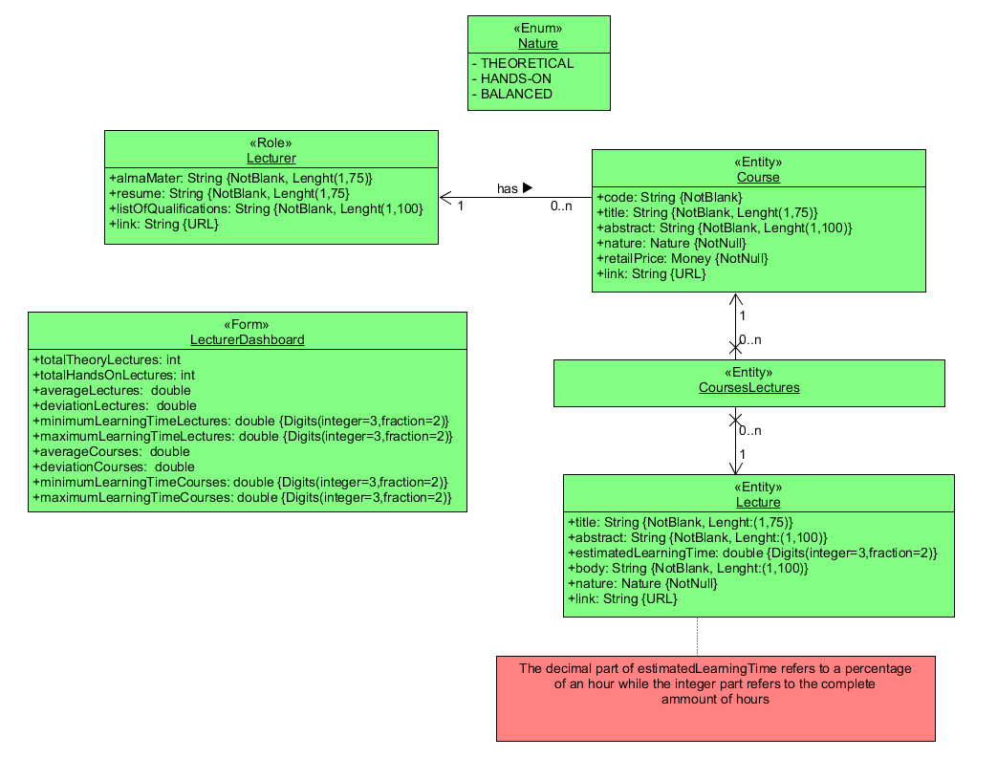

For this set of requirements I decided to make an individual UML model to represent each of the entities and classes needed for the deliverable, including their attributes, relations and restrictions.

1. **Conclusions**

These were the overall details of the performed individual task by the member Carlos Zarzuela Reina.

1. **Bibliography**

* Discussion board:

https://ev.us.es/webapps/discussionboard/do/forum?action=list_threads&course_id=_63009_1&nav=discussion_board&conf_id=_303964_1&forum_id=_206215_1